Grab All : Real Time Advertising Application

Areeb Akhtar
Comp Student, Dept of
Computer Engineering
VCET
areebakhtar89@gmail.com
Shubham Patil
Comp Student, Dept of
Computer Engineering
VCET
shubhamdpatil59@gmail.com
Sangita Chaudhari
Himanshu Wadekar
Compt Student, Dept of
Computer Engineering
VCET
himanshuwadekar1@gmail.com

Assistant Professor,Dept of ComputerEngineering
VCET
sangita123sp@gmail.com

Abstract— The inspiration for each location based data framework is: "To help with the specific data, at opportune spot continuously with customized arrangement and area affectability" Right now, are managing palmtops and Android, which will swap the massive work areas in any event, for computational purposes. We have huge number of utilizations and use where an individual sitting in a side of the road bistro needs to get significant information and data. Such needs can only be catered with the help of Location Based Services. A very appealing application includes technology where instant information can be retrieved for the user from the area set by the user. These are the information of the vendors in the range set by the user. The application gives a list of offers with the offers and vendor detail. It shows the address of vendor, validity of the offer, search option for searching some specific or desired offers. It also has a review system where users can give the review of the offers. The average of this review will be shown to each user whenever users open that vendor’s window. We should guarantee that an individual when visiting places need not convey the movement guides with him. All the data must be accessible in his cell phone and furthermore in client tweaked group.The information or offers must time and money efficient for the users.
Keywords— google api, web-server, client, vendor, location., Location Based Services(LBS)

Introduction
Lots of local vendors/ shopkeepers are suffering losses due to various online websites. The main constraint is that, the people are not aware about the offers on the desired products and their prices. Also, they are unaware about the places where they could get the product. Also, there is no such online platform to connect local vendors with people. To solve this problem, we use location-based services. LBS can be characterized as "A remote IP administration that utilizes geographic data to serve a versatile client, any application administration that misuses the situation of a portable terminal." In mobile data services Location Based Services (LBS) is emerging as an important technology due to quick growth in wireless communication and location positioning technologies. Depending on the location of the mobile, Location Based Services (LBS) deliver information which plays a key role in this mobile information era. The LBS services has wide range of applications, such as health, entertainment, personal life, work, etc. It is also used to find out the persons or objects location, such as discovering about a restaurant or a grocery shop or a mall. LBS have two major actions, that is: Obtaining users location Provide a service by utilizing this information. The above actions can be used to obtain information such as:
1. Where the user is?
2. Where is the nearest place?
3. How to reach the nearest place?

PROBLEM STATEMENT
Due to increase in online shopping the business of the local vendors has declined to a greater extent. One of the main reason why the online shopping got the boost is that, the people didn’t knew from which shop to buy their desired item. The aim of this project is to develop a run-time advertiser android application for the upliftment of the business of local vendors and shopkeepers. The goal is to create a platform where the local vendor can get his target customers easily and customer( user) can easily find out which product is available at which shop in its surrounding. It focus on breaching the gap between the customer and the vendor.

LITERATURE REVIEW
These frameworks offer data to sightseers considering their present areas. Location Based Services (LBSs) offer customized types of assistance to the endorsers dependent on their present position utilizing Global Navigation Satellite System (GNSS), Geographic Information System (GIS) and Wireless Communication (WC) innovations. LBS offers present day world the device for effective administration and nonstop control [1]. The advancement and spread of Smartphones is without a doubt one of the most striking improvements in data and correspondence advances over the most recent few decades. Inside the different utilizations of Smartphone stages, location based services are prevalent as they essentially work in situating and route, helping numerous applications associate with clients on a real-time basis. location based administrations can be gotten to through savvy gadgets with a geological situating highlight serving in assorted ways[2]. LBS applications with a wide assortment of plans of action have developed, and LBS and Social Networking Services (SNS) have been consolidated. Besides, location based ads have showed up, empowering location-based commerce (L-commerce), an upgraded form of portable business. Nowadays, generally on the web/versatile data administrations, for example, entrances, maps, SNS, and online business repository, give mentioned data dependent on the clients' location data [3]. Web administrations are another type of Web applications. They are self-depicting, independent, measured applications that can be found, distributed, and summoned over the Web. Web administrations perform functions that can be anything from basic solicitations for data to making and executing muddled business forms. When a Web administration is conveyed, it very well may be found and conjured by different applications [4].

METHODOLOGY

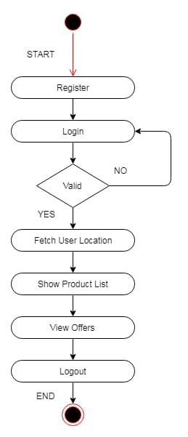
Fig [1] Flow of the application
Grab All is an android application using Location Based Services (LBS). Here the user (customer) can view offers from the various nearby shops using this application. The user has to register and then login to the application to use the application services. Once the user registers and logs in into the application it can set a specific range, then the offers of registered shops in that set range can be seen by the user. The category of the vendor can also be seen by the user. The flow or process of the application is shown in Fig. 1.

The back-end consists of a website. The admin acts as the main control at the back-end. The vendor contacts the admin and then Admin registers the vendor on the website. After this the vendor then logs into the system and then uploads the offer and sets the validity period of the offer. Addition or updation of the offers is been performed by vendor.

V. ARCHITECTURE

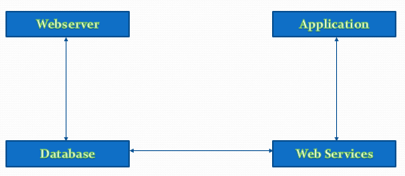
Fig [2] Architecture of the Project
Web services are followed by contact between the mobile client and the server-hosted website. A structured HTTP application layer protocol GET method request is sent to the API by the smartphone application which takes the arguments and instructions. The API connects to the database and queries the data required based on the arguments received. Among other details these statements express the user's geolocation co-ordinates. The API compiles an answer in the form of a standardized set of elements based on those instructions and arguments. Such elements contain information that the mobile application requires to show a list of locations which can be checked in more detail by the user than further. Some detailed information sets is provided by API when the smartphone application requests such details. The diagram shown in Fig. 2 Exemplifies a simplified definition of communication between our website and the smartphone app that web services. The diagram's server side represents a database abstraction, with a bidirectional relation between the GIS API program and the database.
VI. TECHNOLOGY
Android is the main open source versatile application stage that in different markets can possibly make significant advances. Android has solid APIs, dependable documentation, a committed network of engineers, and no expense of creation or conveyance. Android sits close by another flood of versatile working frameworks intended for progressively ground-breaking portable equipment. Android offers new prospects for versatile applications by offering an open improvement condition based on an open source Linux bit. Equipment get to is accessible to all applications through a progression of API libraries, and application communication, while painstakingly controlled, is completely upheld. In Android, all applications have equivalent standing. Outsider and local Android applications are composed utilizing a similar APIs and are executed on a similar run time. Clients can evacuate and supplant any local application with an outsider engineer elective. [1]

The Global Positioning System (GPS) utilizes a heavenly body of satellites circling the earth. GPS finds the client position by figuring contrasts in the occasions the signs, from various satellites, take to arrive at the collector. GPS signals are decoded, so the advanced mobile phone must have in-manufactured GPS beneficiary. GPS takes help from GPRS and now and again, the specialist co-op organize data, to stick point the present area precisely. In addition, the measure of CPU and programming required for a GPS telephone is diminished by redirecting a large portion of the work to the help server. A run of the mill GPS empowered PDA utilizes GPRS or other such Internet based information association with construct a contact with the help server. As this system doesn't consider the mobile phone specialist co-op arrange totally, we just compensation for the GPRS utilization charges and that's it. GPS limits the measure of memory and equipment that must be incorporated into cell phones so as to give GPS-quality gadget finding capacity as required by cell phones. This keeps the cell phone basic and permits longer battery time. GPS is ongoing arrangement supplier. The system use is required each time we move out of the administration region. It is helpful just for finding a specific spot in little zone.

MySQL is a Relational Database Management System (RDBMS) that runs as a server giving multi-client access to various databases. SQL was first evolved to work on information in databases that follow the social model. It is a programming language for questioning, altering and overseeing information. MySQL is the most well-known open source database apparatus. It is viewed as a simple and solid program contrasted with other database programming. MySQL offers different various projects that are database related.

PHP (PHP - Hypertext Pre-processor) is a specific scripting language, principally utilized for the advancement of dynamic site pages. Its key job is powerfully producing HTML code, yet it has numerous different applications. By utilizing PHP, it is conceivable to make a HTML page with progressively chose and organized substance. Along these lines, the PHP code, which had created the page, can't be gotten to by the client. The client can watch just the yield, which is the results of a PHP content execution. The PHP language is like that of the C programming language. A significant number of the highlights accessible in C are likewise present in PHP. The most perceptible is its capacity to be utilized as a procedural language. In any case, PHP can likewise be utilized in an article arranged way. PHP is accessible on most significant stages, for example, GNU/Linux, Mac OS X and Windows.

Web services innovation is changing the Internet, expanding with abilities to create the value-based web. This change is being powered by the program to program correspondence model of Web administrations based on existing and rising norms, for example, Hyper Text Transfer Protocol (HTTP), Extensible Markup Language (XML), Simple Object Access Protocol (SOAP), Web Services Description Language (WSDL), and the Universal Description, Discovery, and Integration (UDDI) venture. Web administrations are effectively applied as a wrapping innovation around existing applications and data innovation resources, new arrangements can be sent rapidly and recomposed to address new chances. As reception of Web administrations quickens, the pool of administrations will develop, cultivating improvement of progressively powerful models of in the nick of time application and business incorporation over the Internet. A Web administration is an interface that portrays an assortment of activities that are organize open through institutionalized XML informing. A Web administration plays out a particular undertaking or a lot of errands. A Web administration is depicted utilizing a standard, formal XML documentation, called its administration portrayal, that gives the entirety of the subtleties important to cooperate with the administration, including message arranges (that detail the tasks), transport conventions, and area.

The User chooses the reliable service type i.e. Location Based Services as shown in Fig. 3. Location Based Services uses GPS to search positions. The Server Location Based Services stores the location. The Location Based Services changes the location in the database when the user is traveling or changing location. Whenever the user opens the tab, the Location Based Services will show the user the nearest location. The user checks for other services provided by the Location Based Services.

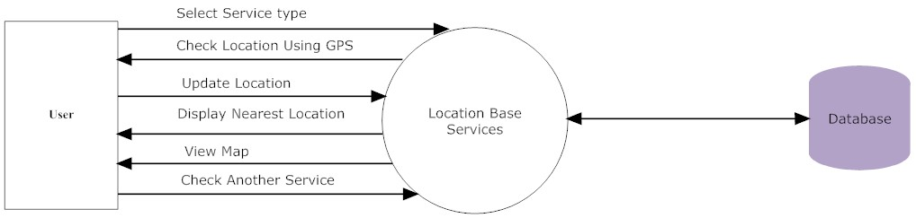
Fig [3] Client (user) Side Process

VII. CONCLUSION

In this paper we shown what is Location Based Services(LBS) and how it can be used to solve the problem. Earlier the only use of mobile phone was voice communication, but now voice communication is just one aspect of a mobile phone. There are other major factors such as web browser and GPS services. With the consideration of these factors ‘Grab All’ is implemented. ‘Grab All’ helps to reduce the game between the vendor and the customer by providing the vendors a platform to reach out to all the customers in the nearby area. Also it makes the task of the customer easy, as the customer can easily find out from whom to buy the desired product and who the vendors are and also the vendors location. Hence the business of the local vendors is enhanced and the customer service is made easy.

VIII. References

[1] Sandeep Kumar, Mohammed Abdul Qadeer, Archana Gupta Department of Computer Engineering Zakir Hussain College of Engineering and Technology Aligarh Muslim University, Aligarh 202002, India
[2] https://pigeon.srisys.com/blog/types-of-location-based-services
[3] Choong C. Lee Graduate School of Information Yonsei University 50 Yonsei-ro, Seodaemun-gu, Seoul,120-749, Korea
[4] Hongbing Wang, 1, 2, 3 Joshua Zhexue Huang, 3 Yuzhong Qu, 2 Junyuan Xie, 1 1 Department of Computer Science and Technology Nanjing University Nanjing 210093, China
[3] Gartner, G.; Huang, H. Progress in Location-Based Services 2016; Lecture Notes in Geoinformation and Cartography; Springer: Berlin/Heidelberg, Germany, 2017.
[4] CartouCHe, Stefan Steiniger, Moritz Neun, and Alistair Edwardes, "Foundations of Location Based Services," London, UK: SpringerVerlag, 304-307.
[5] André Malm , Mobile Location-Based Services, 9th ed.: Berg Insight AB No.146 @ "http://www.reportlinker.com/p0203495/Mobile-LocationBased-Services-Edition.html", 2015.
[6] Vladimir Lazović, Nikola Minić, Milan Tair Singidunum University, 32 Danijelova St., Belgrade, Serbia
[7] Manav Singhal, Anupam Shukla, 1ABV-Indian Institute of Information Technology and Management Gwalior, India
[8] https://www.engpaper.com/mysql-database-very-good-thesis.html

